## Building a Starter Portfolio

## **Case Study Checklist**

1. **Articulate Portfolio Purpose**
   * Describe what a portfolio is used for.
   * Explain what a portfolio demonstrates.
2. **Create Project Case Study**
   * Balance text and visual content (30:70 to 70:30 ratio).
   * Include project name.
   * Include project duration.
   * List tools used.
   * Provide project challenge or problem statement.
   * Detail design process phases:
     + Research
     + Discovery
     + Definition
     + Prototyping
     + Concepts
     + Testing
     + Iteration
   * State project solution or outcome.
   * Use clear visuals (no blurry, pixelated, or dark photos).
   * Include prototype link or high-fidelity wireframes.
3. **Create “About Me” Page**
   * Write a short paragraph about yourself.
   * Include design philosophy or influence.
   * Describe design process or approach.
   * List relevant skills.
   * Mention professional experience (if applicable).
   * State education (if applicable).
   * Include personal and/or professional interests.
4. **Learning Reflection Write-up**
   * Reflect on project design process, decisions, and outcomes.
   * Answer the following:
     + What was your process?
     + What skills or expertise did you use?
     + What key activities happened in the project?
     + What interesting or critical insights or findings did you encounter?
     + What key tradeoffs or decisions did you make?
     + What constraints or challenges arose?
     + How did you arrive at your solution or conclusion?
     + What impact did your design have?
5. **Enhance Project Presentation**
   * Include user research, design, prototyping, and testing.
   * Capture key insights and findings.
   * Create captions for visual content.
6. **Prepare Online Portfolio**
   * Complete an online version of the case study.
   * Include the “About Me” page online.
7. **Expand Portfolio Content**
   * Include a second project case study.
8. **Final Review**
   * Ensure the portfolio tells a compelling story.
   * Highlight contributions, skills, and project impact.

**Challenge or Problem Overview**  
In the rice management industry, handling processes from harvest to distribution presents several challenges. Key issues include accurately tracking the harvest process, efficiently managing inventory, and processing orders swiftly. Particularly, managing data related to harvested quantities, inventory levels, and current orders can become complex and prone to errors without an appropriate support system.

Currently, many rice management systems rely on manual methods or non-integrated tools, leading to time inefficiencies, difficulties in tracking and reporting, and data errors. The lack of synchronization between departments and management tools results in reduced operational efficiency, affecting the ability to respond quickly to market demands and manage resources effectively.

Our "Rice Management" project aims to address these challenges by developing an integrated user interface that enables comprehensive management of processes, from harvesting and inventory tracking to order processing and sales invoicing. The goal is to create a user-friendly, efficient system that integrates essential functions to optimize management processes and support business decision-making.

### Research & Analysis

To address the challenges in rice management, a thorough research and analysis phase is crucial. Our approach involves examining existing systems, understanding user needs, and identifying gaps in current practices. The research focuses on several key areas:

1. **Current Systems and Tools**: We analyzed existing rice management systems to understand their functionalities, limitations, and user feedback. This analysis includes evaluating both manual and digital solutions, identifying common pain points, and assessing the efficiency of different tools.
2. **User Needs and Preferences**: By conducting interviews and surveys with stakeholders such as farmers, inventory managers, and sales personnel, we gathered insights into their specific needs and preferences. This helps in designing features that address real-world challenges and improve user experience.
3. **Process Mapping**: We mapped out the entire rice management workflow, including harvesting, inventory management, order processing, and sales tracking. This process mapping highlights areas where inefficiencies occur and where integration can streamline operations.
4. **Competitive Analysis**: We reviewed competitor systems to understand the features and functionalities they offer. This competitive analysis helps in identifying best practices and opportunities for differentiation in our solution.
5. **Technological Trends**: We explored current technological trends and tools that could enhance the rice management process. This includes advancements in data integration, automation, and user interface design.

Using Miro as a collaborative tool, we have visualized our findings and organized information to facilitate ideation and design. Miro has been instrumental in creating a visual representation of the research data, brainstorming solutions, and developing user flow diagrams that guide the design process.

Miro: https://miro.com/welcomeonboard/SUs1SUxyeG1KbzRWOWRoS1V1eVR6bEd6cjh1UnJMeVh3SDJuTFRiakg0bzBFQ2hRQXNHOWNZcndVeER3SU1naHwzNDU4NzY0NTk2NzEzNDQxMjY1fDI=?share_link_id=204881037330

### Design

We have developed a high-fidelity prototype of the product using figma. Please use link mentioned below to have a look at the prototype

1. Style Guide

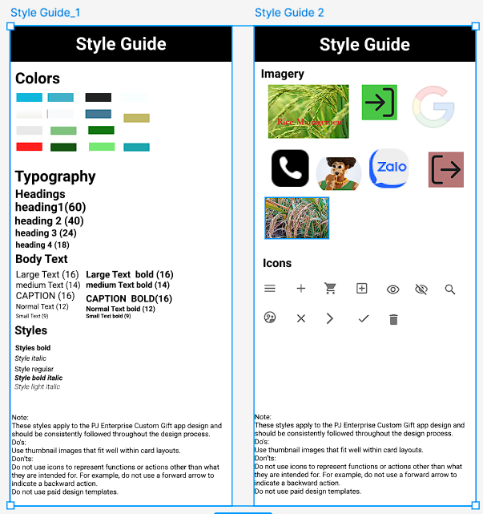

1. Partern Lib  
   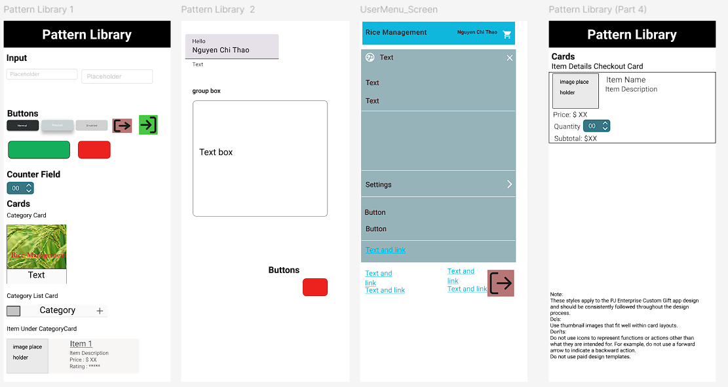
2. Login state  
   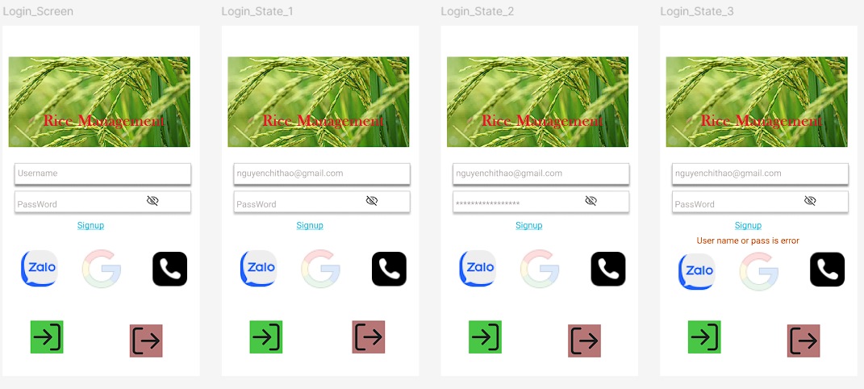
3. Sample flow : Payment Flow  
   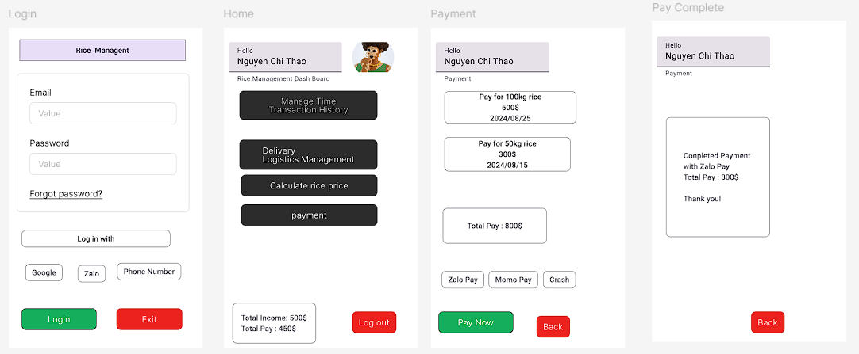
4. Fima all resource: https://www.figma.com/design/1RU0f9hi2Q38H7qssKeaa3/C3_Final_Project_Rice_managerment?node-id=2003-270&t=h7Iv5fty23LiPZN5-1
5. Figma Proto : <https://www.figma.com/proto/1RU0f9hi2Q38H7qssKeaa3/C3_Final_Project_Rice_managerment?node-id=2003-449&node-type=CANVAS&t=h7Iv5fty23LiPZN5-0&scaling=min-zoom&content-scaling=fixed&page-id=2003%3A270>
6. Payment Flow: <https://www.figma.com/proto/ZycpJVEazEtJ50ZLHN4Y0B/PaymentFlow?node-id=2003-449&node-type=CANVAS&t=EDeyChdNonwbGgyh-0&scaling=min-zoom&content-scaling=fixed&page-id=2003%3A270>

### About Me

Nguyễn Chí Thảo is a seasoned Project Manager with over 10 years of experience in the field. Fluent in both English and French, Thảo specializes in capturing and translating client requirements into actionable tasks for the team. With a strong background in project management, Thảo ensures efficient execution and delivery of projects. Thảo’s expertise in communication and client relations contributes significantly to project success.